Configuring iDrac Monitoring By INC
The following steps outline the necessary configuration to iDRAC to allow monitoring by INC
Verify the iDRAC templates are loaded to perform the monitoring.
- Log into INC
- Log into the client
- Expand Configuration/Monitoring and click on Service Templates
- Verify the template “Dell Servers using iDRAC” is listed.
Configure iDRAC on the Hardware
- Log into iDrac
- Expand iDRAC Settings.
- Click User Authentication
- Click a Disabled user ID
- Ensure Configure User is selected and click Next
- Click Enable User
- For Username enter Impact
- For the passwords enter a complex password
- Under IPMI User Privileges set both drop downs to Administrator and check Enable Serial Over LAN
- Under iDRAC User Privileges change Roles to Administrator
- Click Apply
- Log out
- Log in using the Impact account
- Expand iDRAC Settings.
- Click User Authentication
- Click the root user.
- Click Next
- Select Change Password and enter a complex password.
- Click Apply
- ***Enter both passwords into IT GLUE
- Under iDrac Settings select Network
- Under the Options menu select Advanced Settings
- Click Services
- Scroll down to SNMP.
- Use the following settings.
  - Enabled: Checked
  - SNMP Community Name: Impact
  - SNMP Protocol: All
  - SNMP Discovery Port Number: 161

Enable monitoring in INC
- Perform a discovery scan in INC for the iDRAC IP.
- Import the device. If the Device Class is Other, change to Servers – Management Interface
- Select the device and go to the Monitoring tab.
- Click Add
- Select the following:
  - BIOS (Dell iDRAC) – Add 1
  - CPU Status (Dell iDRAC) - Add 1 for each physical CPU.
  - Memory Status (Dell iDRAC) - Add 1 for each memory stick installed.
  - Physical Drive (Dell iDRAC) - Add 1 for each drive installed in the server.
  - Power Supply (Dell iDRAC) - Add 1 for each power supply installed.
  - Temperature Status (Dell iDRAC) - Add 1
- The devices will show in Monitoring. Services that had more than one added will be duplicated. For instance, if there are 2 CPUs then both will currently be listed as CPU Status (Dell iDRAC) – CPU.Socket.1
- The following will be for changing the second CPU Status service to point to the second CPU
  - Click on the second CPU Status (Dell iDRAC) – CPU.Socket.1
  - Click the Service Details tab
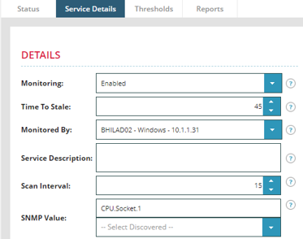
  - Under SNMP Value click the drop down for Select Discovered
  - Select CPU.Socket.2
- Click OK
- The change should now be reflected in the monitoring section.
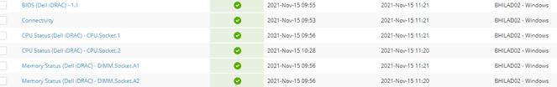
- Perform the changes for all of the other services.
- The Physical Drive monitor may need one more modification. The Used Space Percentage may always show at 100%, triggering a failure. Perform the following to turn off that threshold.
  - Click on the drive.
  - Click the thresholds tab.
  - Under USED SPACE PERCENTAGE change Monitoring to Off
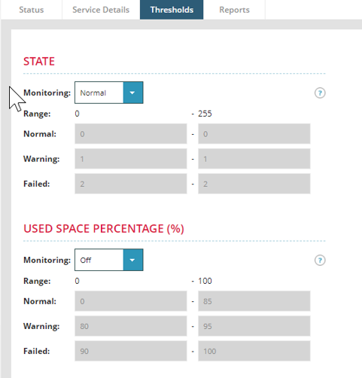
  - Click OK

